**Guidelines To Execute IPC Test Cases**

**Software's need to be installed:**

1. VSCodeUserSetup-x64-1.82.2.exe(Visual Studio Code)
2. Python310
3. VehicleSimulator_v5_0_1.exe
4. qnx-setup-201808201144-win1.exe(QNX Momentics)
5. DeviceController_v0.5.zip(to check the device display)
6. Unzip and install the below files

qud.win.1.1_installer_10053.9.zip

qpst.win.2.7_installer_00480.14.zip

1. Open the visual studio code then install the below marked extensions

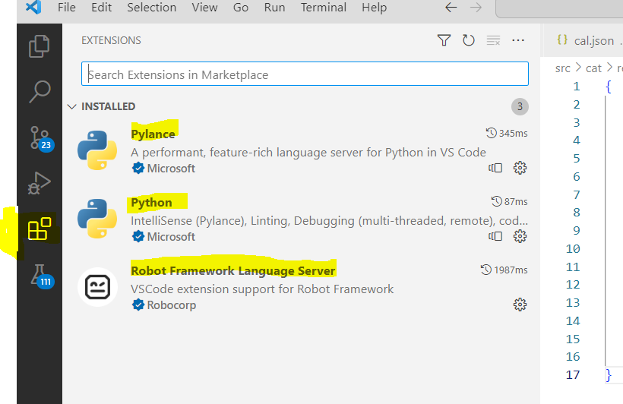

1. Please find the following one drive link to install software's

[IPC Softwares](https://rampgroups-my.sharepoint.com/:f:/g/personal/satyadevi_rayudu_rampgroup_com/EsepiQ3TMhFAujuE8CrpR34BBgxrkD8nZ2gYqiYxThDrhg?e=xyVufu)

1. In visual studio code click the Ctrl+Shift+p then search for python select interpreter and Robot frame work:clear caches mentioned below image.

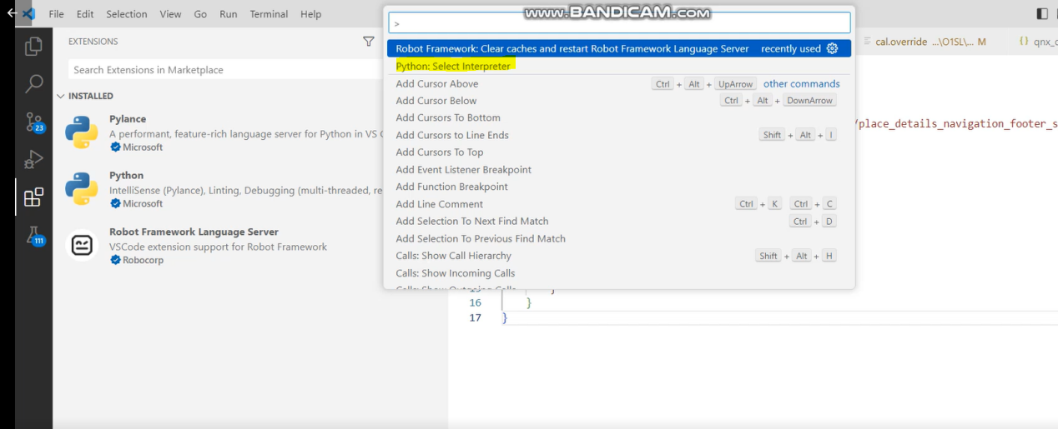

1. After installing VS-Code, open terminal in visual studio code run the following command **“pip install -r requirements.txt”**

**Setup Hardware Connections before start execution:**

1. QNX should be in connected state in QNX Momentics
2. Vehicle Simulator should be connected and in Run state
3. adb device should be connected.
4. Save ABC number in phone, it should be top of the recent call list then connect BT phone to the device(for sanity tc’s only).
5. Don’t connect Android Auto and Carplay(for sanity tc’s only).
6. Connect Wi-Fi to the android device(for sanity tc’s only).

**Files to set up before start execution in different variants:**

Unzip the code, open Visual Studio code->click on File->click on open folder->select the Cluster Automation Tool folder.

1. Go to **cat_config.py** file which is placed under cat folder change the below properties for executing variant.

Ex:

display_size = "34in"

vehicle_program = 'O1SL'

adb_devices = '719b869a'

com_num = '22'(tera term port)

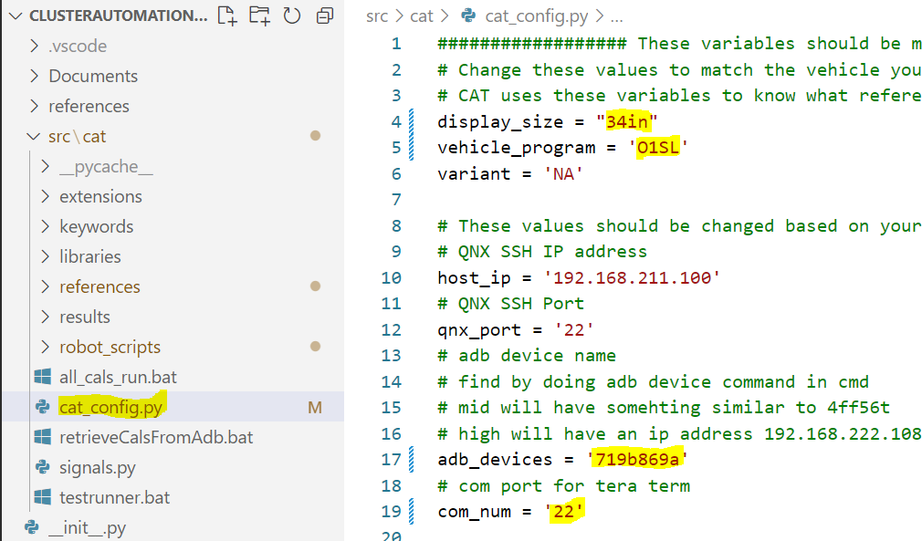

1. Go to **libraries\qnx\qnx_coordinates.json** file search with variant name(ex:search with L233) qnx coordinates available for the executing variant, if available no need to change anything then go to the step 4
2. If qnx coordinates not available change the coordinates according to variant(we can use the same coordinates for same display size for example we can use L233 coordinates for L232, except 34 inch L233 RHD)

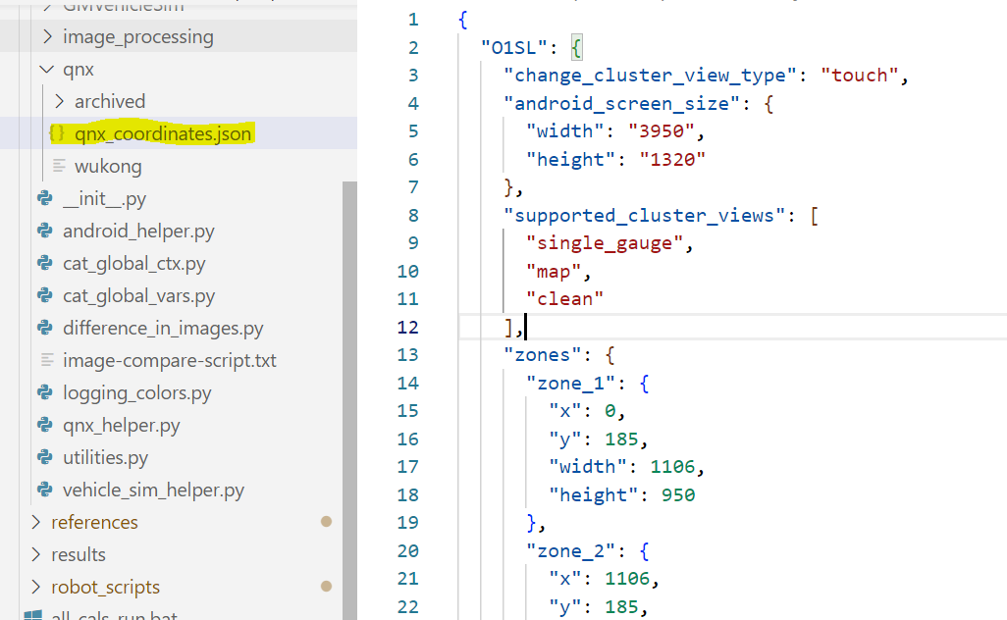

1. Go to references folder navigate to variant folder(ex: 34inch->L233)verify the **cal.override and info.json files** are exist(no need to change anything but verify the files are having correct data as per the variant) then go to the step 5

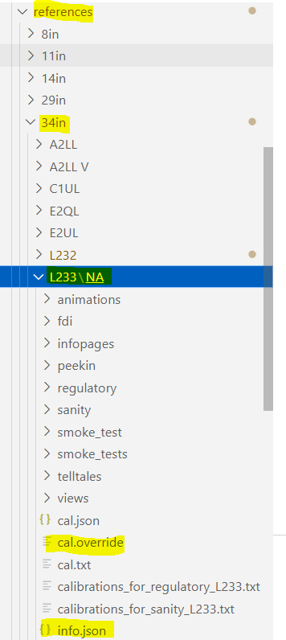

If the **cal.override** and **info.json** files are not available copy and paste them from other variant(ex: copy them from 34inch/L233 variant).

Change the cal.override file calibrations according to executing variant(marked in color)

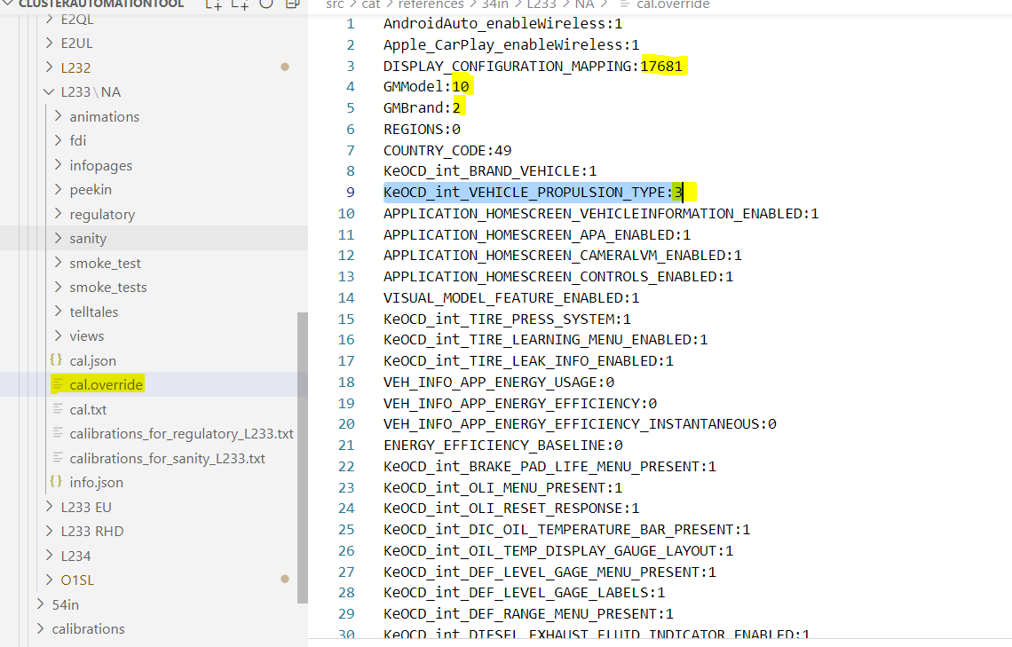

Change the variant name(marked in color) in info.json file according to the changed variant

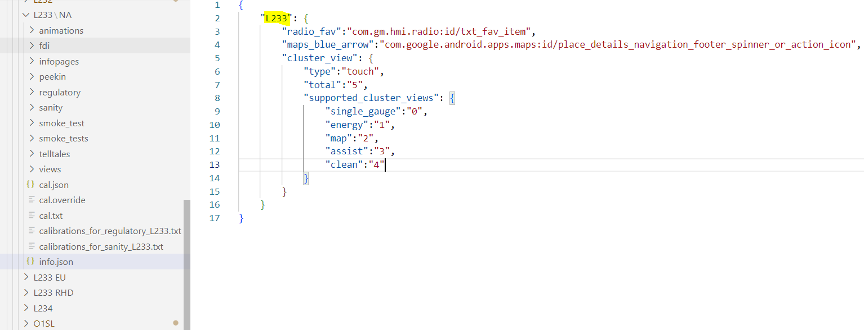

1. For sanity test cases, verify images are exist in the below folder

E:\IPC_Projects\sanjeev_anna_08_23\ClusterAutomationTool\src\cat\references\34in\L233\NA\sanity\single_gauge

1. Clear the caches by click the short cut key Ctrl+Shift+p
2. To execute sanity test cases click the Testing image->click on sanity->click on play button->execution will start

